Output File 1:

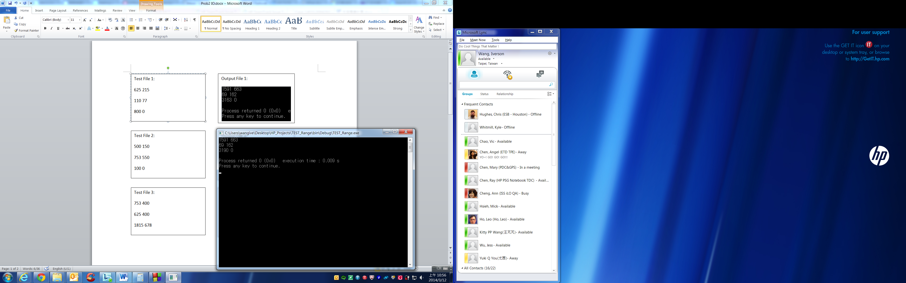

Test File 1:

625 215

110 77

800 0

Output File 2:

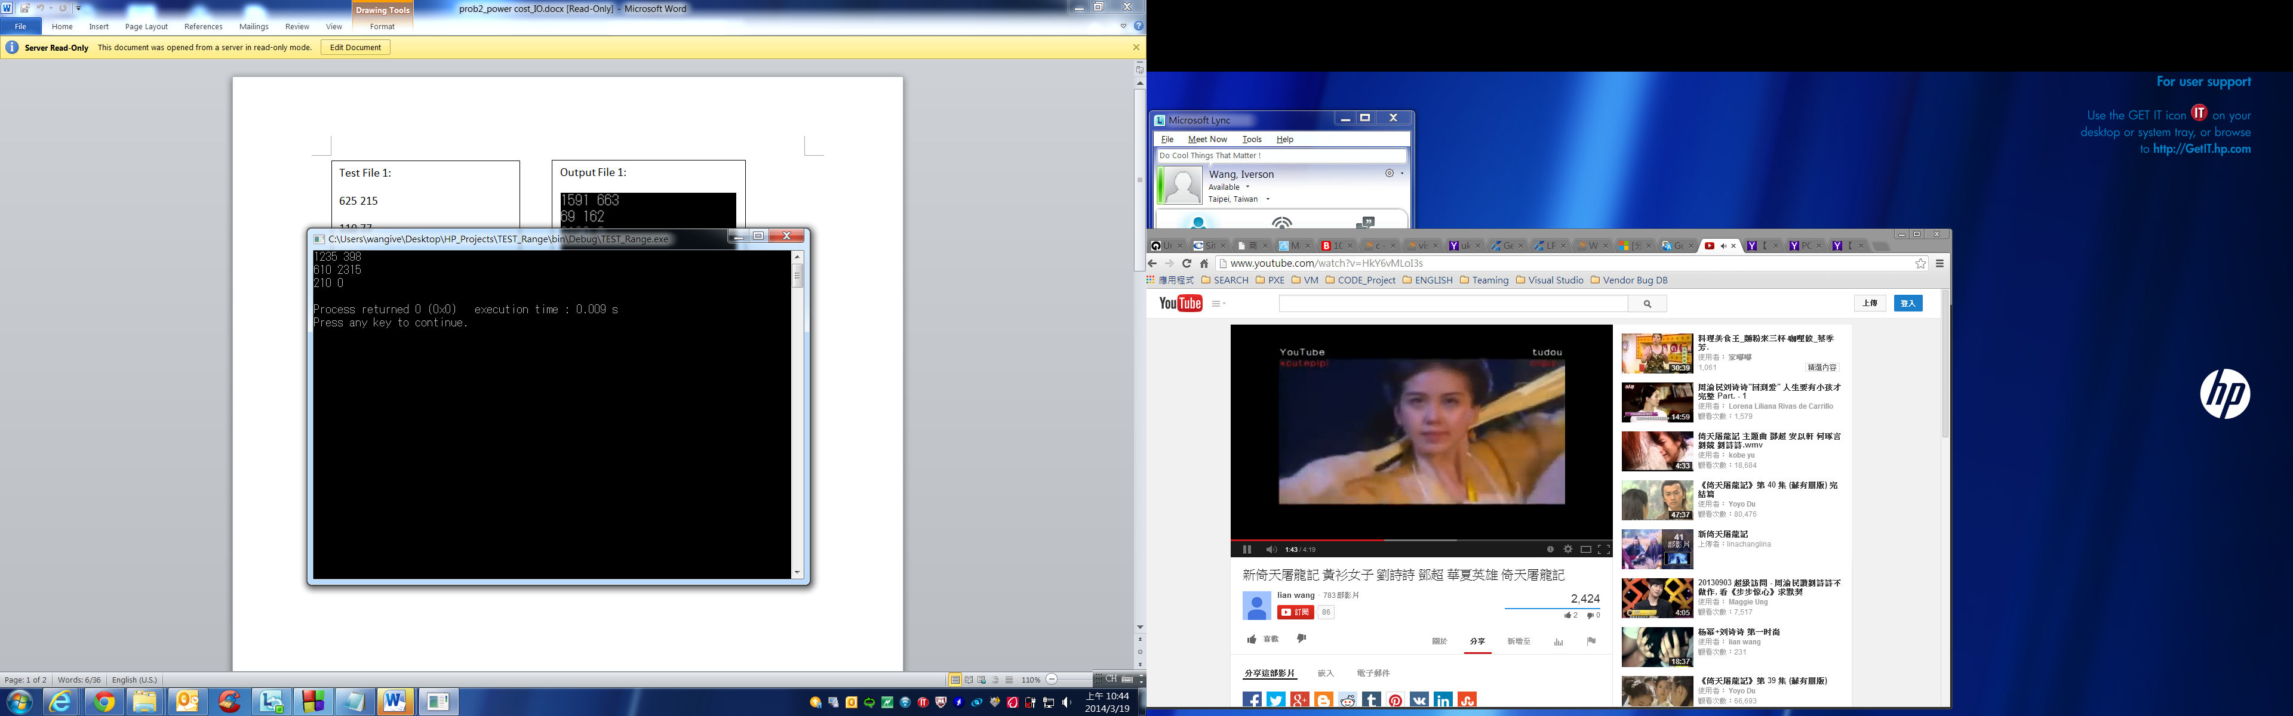

Test File 2:

500 150

753 550

100 0

Output File 3:

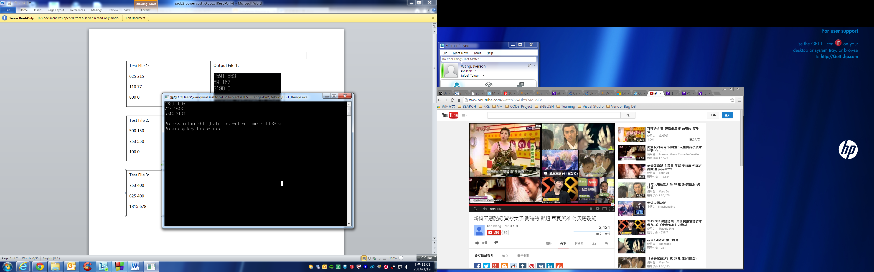

Test File 3:

753 400

625 400

1815 678